Introduction and Dataset Description
The objective of this assignment was to implement a Recurrent Neural Network (RNN) using the LSTM architecture for time series forecasting.
Dataset: I selected the Electricity Load Forecasting Dataset (UCI Machine Learning Repository). The dataset contains electricity consumption measurements (in kW) for a specific client from 2011 to 2014.
Preprocessing Steps: To prepare the data for the neural network, the following steps were taken:
- Resampling: The original data, recorded at 15-minute intervals, was resampled to a 1-hour resolution (1H) by summing the consumption values. This reduces noise and computational load while preserving daily patterns.
- Temporal Splitting: To avoid look-ahead bias, the data was split chronologically:
  - Train Set: Data from the beginning up to 14 days before the test set.
  - Validation Set: The 14 days immediately preceding the test set (used for hyperparameter tuning).
  - Test Set: The final 30 days of the dataset (used for final evaluation).
- Scaling: A MinMaxScaler was applied to normalize the consumption values to the range [0, 1]. Crucially, the scaler was fitted only on the training set to prevent data leakage. The validation and test sets were transformed using the training scaler's parameters.
- Sequence Creation: A sliding window approach was used with a sequence length of 24 hours. The model uses the past 24 hourly readings to predict the load for the 25th hour (Many-to-One architecture).
Model Architecture and Training
I implemented an LSTM-based regression model using PyTorch.
Architecture:
- Input Layer: Dimension = 1.
- LSTM Layers: 2 stacked LSTM layers with a hidden size of 64.
- Dropout: A dropout rate of 0.2 was applied between LSTM layers to prevent overfitting.
- Fully Connected Layer: A linear layer maps the final hidden state of the LSTM to a single scalar output.
Training Configuration:
- Loss Function: Mean Squared Error (MSE), suitable for regression tasks.
- Optimizer: Adam optimizer with a learning rate of 0.001.
- Batch Size: 64.
- Epochs: The model was trained for 50 epochs.
Results and Analysis
The training process showed a consistent decrease in loss for both the training and validation sets, indicating that the model successfully learned the temporal dependencies and periodic patterns (daily cycles) of the electricity consumption.
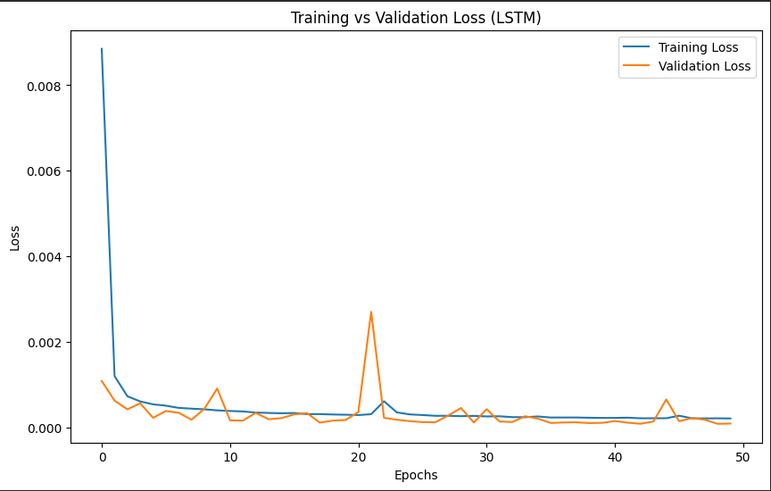
Figure: The Training and Validation loss over 50 epochs.
The convergence of both curves (Training and Validation) indicates that the model successfully learned the temporal dependencies and periodic patterns of the electricity consumption without significant overfitting. The validation loss stabilized alongside the training loss, suggesting the model generalizes well to unseen data within the validation timeframe.

Conclusions
The LSTM model demonstrated strong capabilities in capturing the sequential nature of electricity demand. The use of a 24-hour lookback window allowed the model to leverage daily seasonality. Future improvements could include experimenting with architectures or increasing the sequence length to capture weekly patterns.

